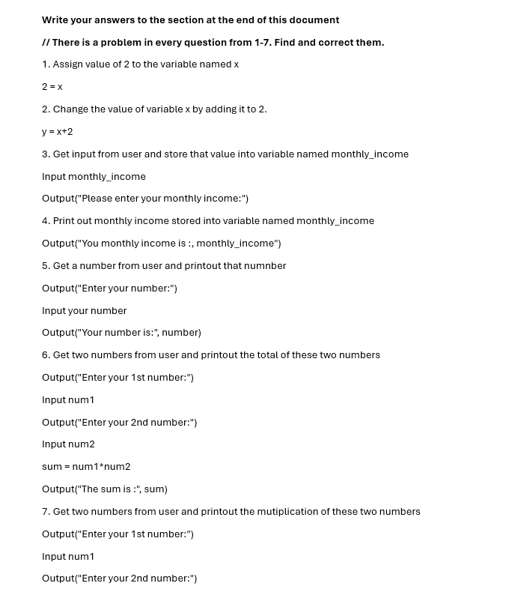

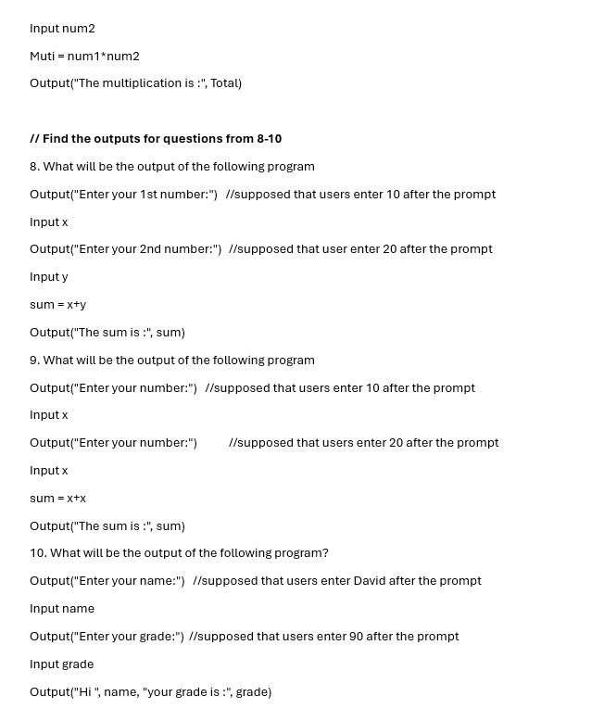
Write your answers and solution here
1. x = 2

2. either (x = x + 2) or (x += 2)

3. Output("Please enter your monthly income: ")
Input monthly_income

4. Output("Your montly income is: ", monthly_income)

5. Output("Enter your number: ")
Input your_number
Output("Your number is: ", your_number)

6. Output("Enter your 1st number: ")
Input num1
Output("Enter your 2nd number: ")
Input num2
sum = num1 + num2
Output("The sum is: ", sum)

7. Output("Enter your 1st number: ")
Input num1
Output("Enter your 2nd number: ")
Input num2
product = num1 + num2
Output("The product is: ", product)

8. The sum is:30

9. The sum is:40

10. Hi Davidyour grade is:90

